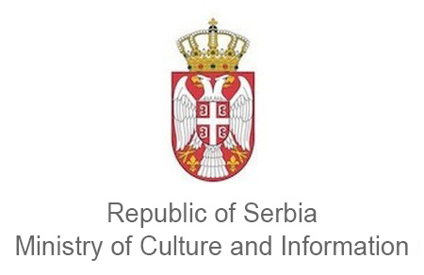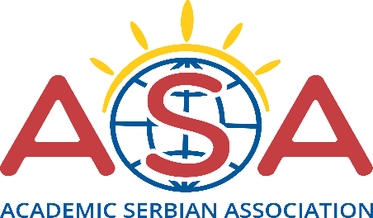

INVITATION TO A FREE THREE MONTH SERBIAN LANGUAGE COURSE VIA SKYPE

Within the project “Learning Serbian as a native language through an online course 2020”, the Academic Serbian Association invites all the people from Serbian diaspora, ages 15 to 19, to apply for a free individual three month Serbian language course via Skype.
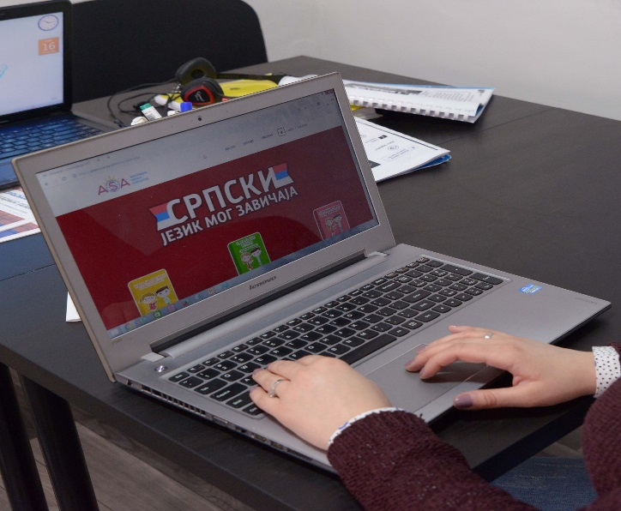

Under the sponsorship of the Ministry of Culture and Information of the Republic of Serbia, we continue to promote and realize online classes. The goal of the project is to promote Serbian language in diaspora through peer education – by carrying out individual classes of Serbian language via Skype, intended for the youth in diaspora.
Serbian speaking people from diaspora, ages 15 to 19, can apply for a free three month Serbian language course via Skype until the 19th of July 2020. During this course their mentors will be teachers from the Academic Serbian Association, accredited by the Ministry of Education, Science and Technological Development. Application requirement is that the students haven’t gone through any Serbian as a native language training course via Skype so far.
The project aims to promote preserving the Serbian cultural and national identity, by carrying out individual Serbian language classes via Skype, to the youth in diaspora, taught by accredited teachers of the Academic Serbian Association.
The course is scheduled to start on 10th of August 2020 and should end on the 31th October 2020. By the end of the course, the students will receive a certificate for a completed course, issued by the Academic Serbian Association.
The classes will be carried out twice a week (the duration of a class being 45 minutes), on dates which the student and the teacher agree on. The Academic Serbian Association will make sure the classes are carried out according to appropriate standards and dynamics.
Anyone interested in the course can fill out the application directly on the website https://asasocijacija.com/prijava-za-besplatan-kurs/ or download it on the ASA website and send it as an e-mail at asasocijacija@gmail.com, titled “Skype classes”.
According to the applications, the Academic Serbian Association will determine the student – teacher pairings.
It is necessary that the potential student has a functioning computer with speakers and a camera, and that the student has a good internet connection, solid English language skills and an ambition to learn. For more information you can contact the Academic Serbian Association at asasocijacija@gmail.com.

